February 21, 2017

Prime Tiger Taekwondo Booster Club
Attention: Melissa Hardy
925 NE Woods Chapel Road
Lee’s Summit, MO 64064

RE: Charitable Organization & Solicitation Law, 407.450 -- 407.478 ROMs, 2000
Registration and Exemption for: Prime Tiger Taekwondo Booster Club
Registration No.: CO-077-17

Dear Sir or Madam:

Based on the facts submitted to our office, it appears the above organization is exempt from registration under the Charitable Organizations & Solicitations Law, Sections 407.450 to 407.478 RSMo 2000. Organizations with this exemption are not required to pay a filing fee or file annual reports to this office.

Your letter and other supporting documents have been retained for our files. In addition, we invite this organization to be included on the Missouri Attorney General’s Check a Charity web page. The web page will offer a profile of each organization, including a description of its charitable purpose, contact information and basic financial information about the organization with a focus on the program-spending ration. Consumers will be able to easily access information that will assist in evaluating solicitations and choosing wisely when responding to charitable appeals.

To be included on the Attorney General’s Check a Charity web page, forms be downloaded at:
http://ago.mo.gov/docs/default-source/forms/jointhecharitydatabase.pdf?sfvrsn=2%20

Thank you for your continued cooperation. If you have further questions please contact the undersigned at (573) 751-1197 or visit us at www.ago.mo.gov.

Very truly yours,
JOSHUA D. HAWLEY
Attorney General
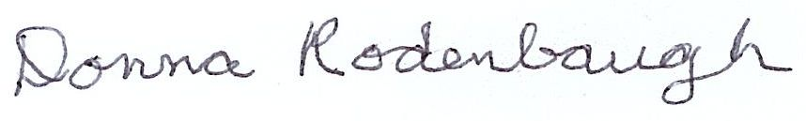
Donna Rodenbaugh
Registration Specialist
Consumer Protection Section

